# Table of Contents

Contents

Table of Contents 1

1.16 - Gripper Adv/Ret Cycle Fault 2

Material Setup 2

Kickout “The scanned box barcode is not valid” 4

# 1.16 - Gripper Adv/Ret Cycle Fault

* Indicates the gripper advance (move to right) cylinder advance reed switch is not working
* It is suggested that this sensor be repaired
* If you choose not to repair the sensor, enable g_par.24

# Material Setup

Only the config for the material you are running should be active (ON). Typically, this is g_par_FilmWidth30in as shown in the screen shot below

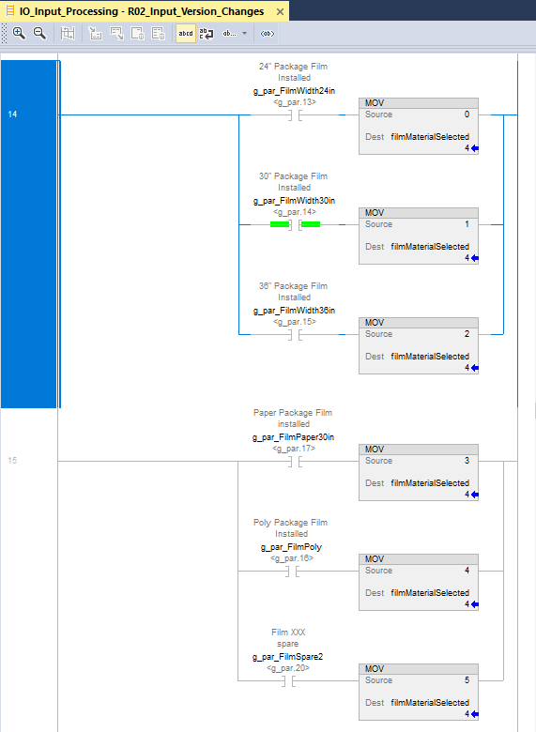

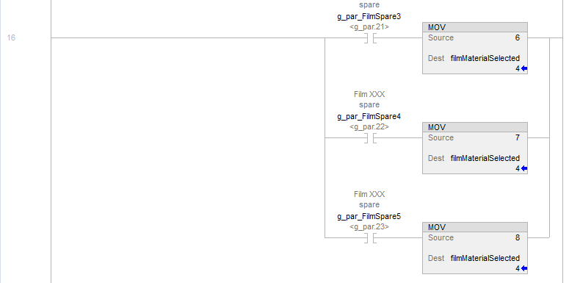

# Kickout “The scanned box barcode is not valid”

